Executive Summary
Daily Learning
Name | M Shahab
Day of Week 1 | 1
Date | 17/11/2025

Summary of Today’s Work
- Covered OOP Chapter 1 and 2
  - Started by watching YouTube videos to understand the fundamentals.
  - Reviewed multiple websites for additional explanations and clarity.
  - Continued studying with ChatGPT for deeper theoretical and practical understanding.
- Concept Mastery Through Multiple Angles
  - Asked ChatGPT to explain every concept from Chapter 1 and 2 in different ways, both theoretically and practically.
  - This helped build a strong understanding of what each concept is, why it is used, and how it works.
- Practice Questions Solved
  - Requested and solved 10 theory questions.
  - Then solved 30 output-based coding questions to test logic and understanding.
- Real-Life Scenario Practice
  - Asked for 10 real-life OOP scenarios to practice implementing concepts for real-world projects.
- Content and Productivity
  - Published a post on LinkedIn.
  - Pushed updated code to GitHub as part of maintaining daily learning consistency.

Youtube Vedios

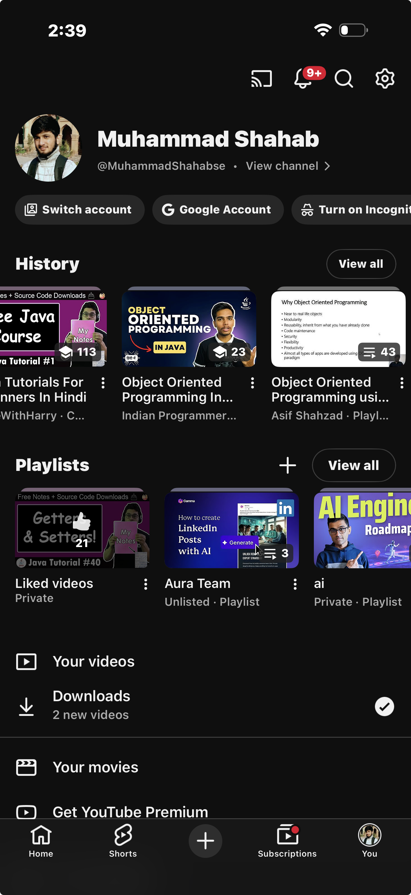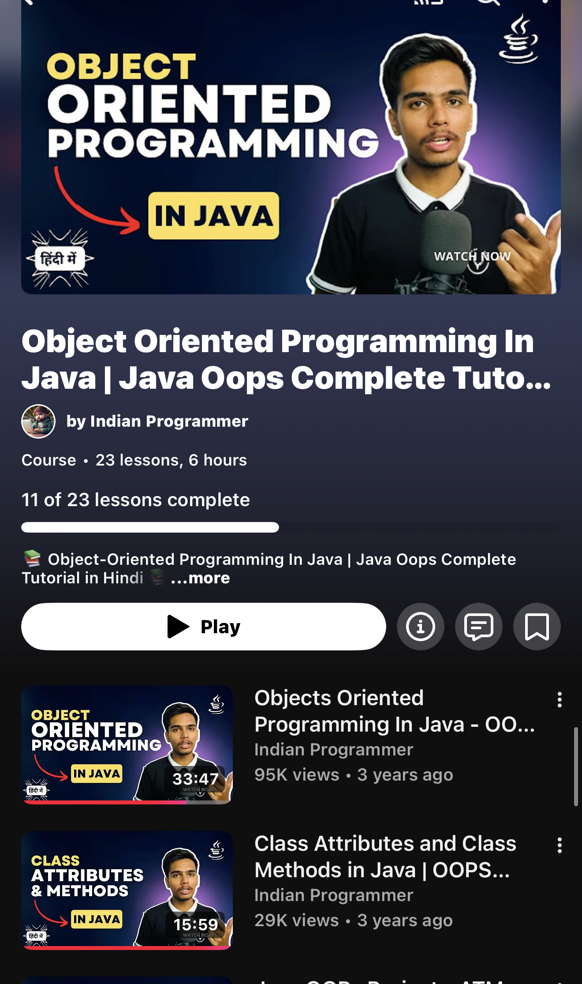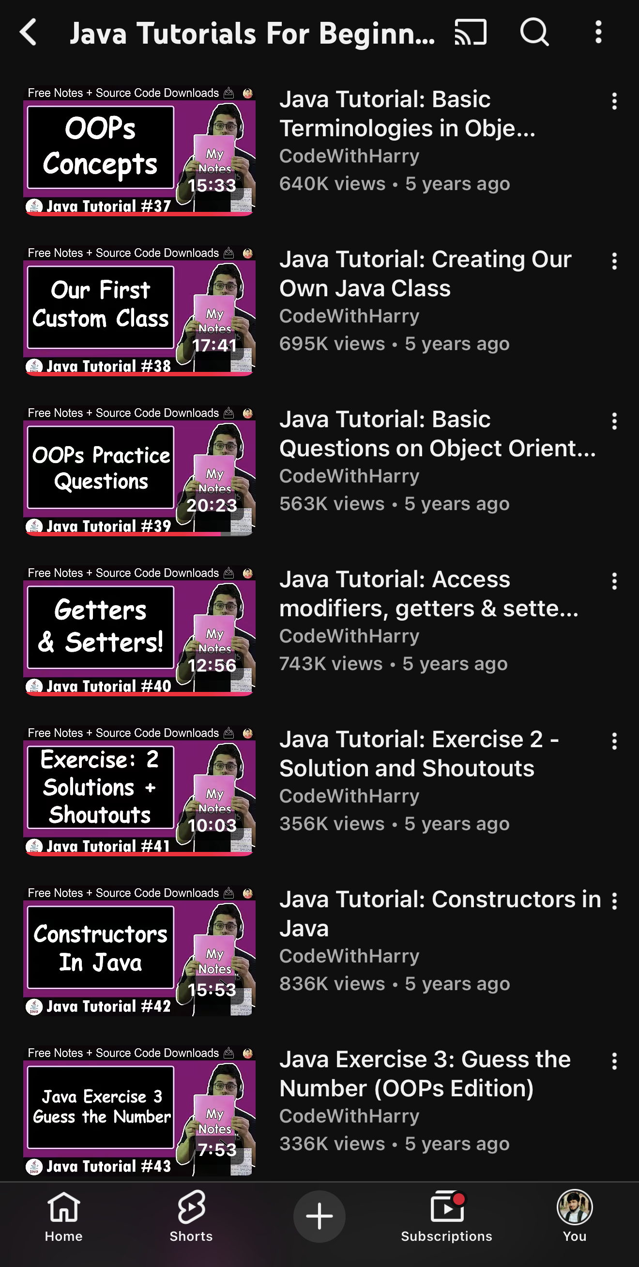

ChatGPT
link of Conversion
https://chatgpt.com/share/691aee3c-2314-8013-8187-9465ddb526fb

